Activity Guide 1 : Part 4

Ryan Coon

CST-407

Professor Ty Howard

December 10, 2023

Part 4: Google Hacking

1. Review the associated resources located in the Topic Resources.
2. Research the phrase “Google Dorking or Hacking” to familiarize yourself with techniques that allow Google to be used as a hacking tool.

A technique that uses Google Search and other Google applications to find security holes in the configuration and code that websites are using.

1. Research the phrase “Go to Jail for Google Hacking” to see what consequences may or may not be related to utilizing a Google Dork result.

There are a plethora of instances concerning Google hacking and their jail times. It ranged from 1 year to up to 20 depending on the amount of damages.

1. Capture a screenshot example of a directory listing of MP3, MP4 or PDF files that were likely hosted unintentionally on a webserver. In the photo caption, explain why you believe this directory probably was not intended to be shared.

I found these Dorking and came from a government directory. I am not too sure that these are public rather more of internal department due to them being top secret at one time.

1. Capture a screenshot example of a SQL backup file from a site. In the caption, highlight the most vulnerable data contained in the backup file.

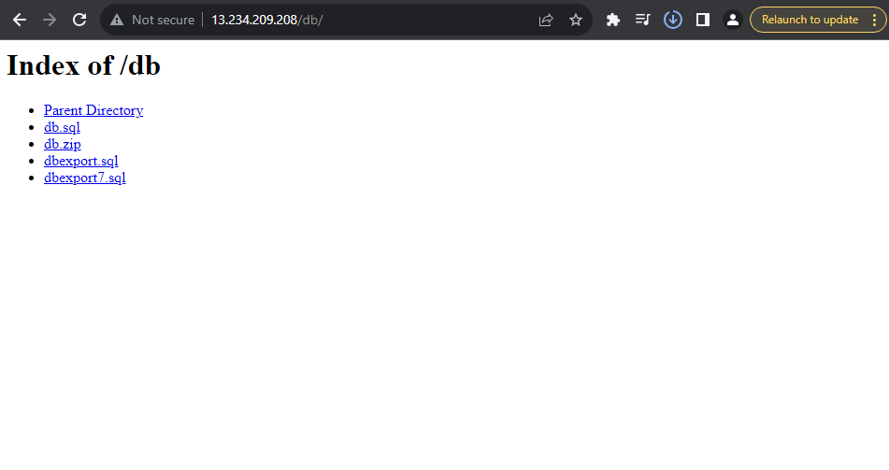

The most vulnerable information that could have been grabbed is the customers’ information. This includes name, address, and bank account information.

1. Explain the process that Google provides users to remove pages from the search results.

Using the console site tool, URL must be in search console property that you own, open the removals tool, select temporary removals tab, click new request, select either temporarily remove URL or clear cached URL then click next to complete the process.

1. What advice does Google provide for permanent removal of search results?

There is not currently a way to permanently remove an URL from google search results. Google advises that you remove or update content on your site to return status 404, block access to the content using a password or indicate that the page should not be indexes using the noindex meta tag (less secure).

1. The **Computer Fraud and Abuse Act (CFAA)** is a U.S. Law that directly addresses the issue of unauthorized access to a computer system. How does the CFAA relate to information obtained by a Google Dork search?

Under the language of CFAA, Google Dorking would not be considered hacking. Whether it is treated as to be legal in court is a question that still remains. “Although it may seem intimidating, Google Dorking is not an illegal activity. ” Per the CFAA, access to publicly available information is perfectly legal.

1. Make sure to properly reference and cite all examples and supporting evidence.
2. Make sure to utilize appropriate industry terminology.

References:

“Brooklyn Law School - Student’s Law Journal Article Examines Legal Issues of “Google Dorking.”” Www.brooklaw.edu, www.brooklaw.edu/News-and-Events/News/2023/03/Students-Law-Journal-Article-Examines-Legal-Issues-of-Google-Dorking. Accessed 17 Dec. 2023.

“What Is Google Dorking/Hacking | Techniques & Examples | Imperva.” Learning Center, www.imperva.com/learn/application-security/google-dorking-hacking/.